STRING ASSIGNMENTS

1. Length of the string:

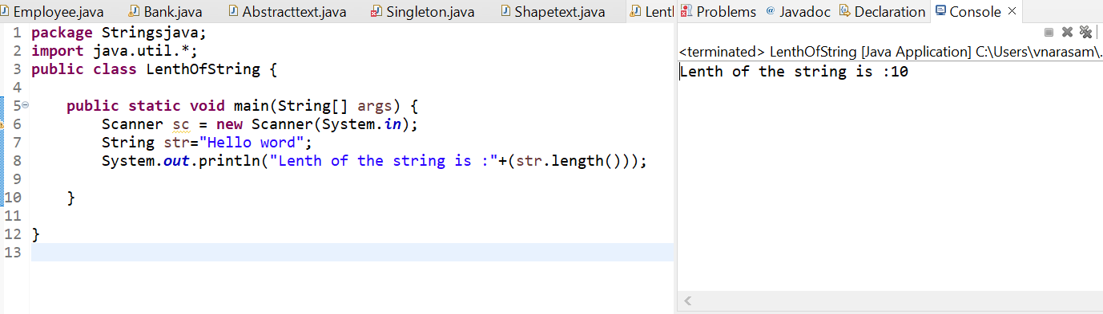

1. Concating of two strings:

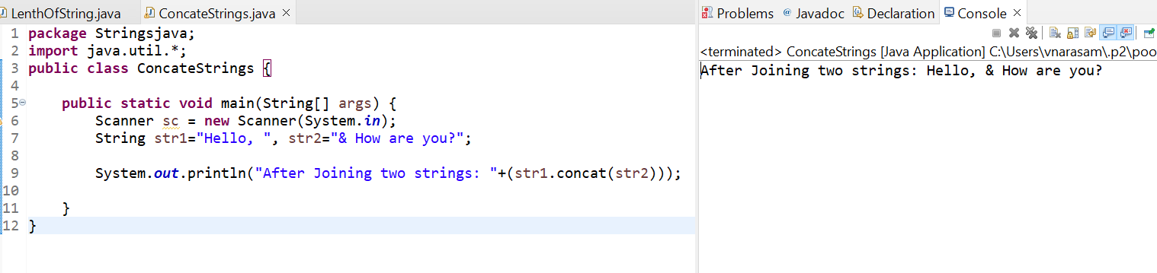

1. The following operations done by using string methods:

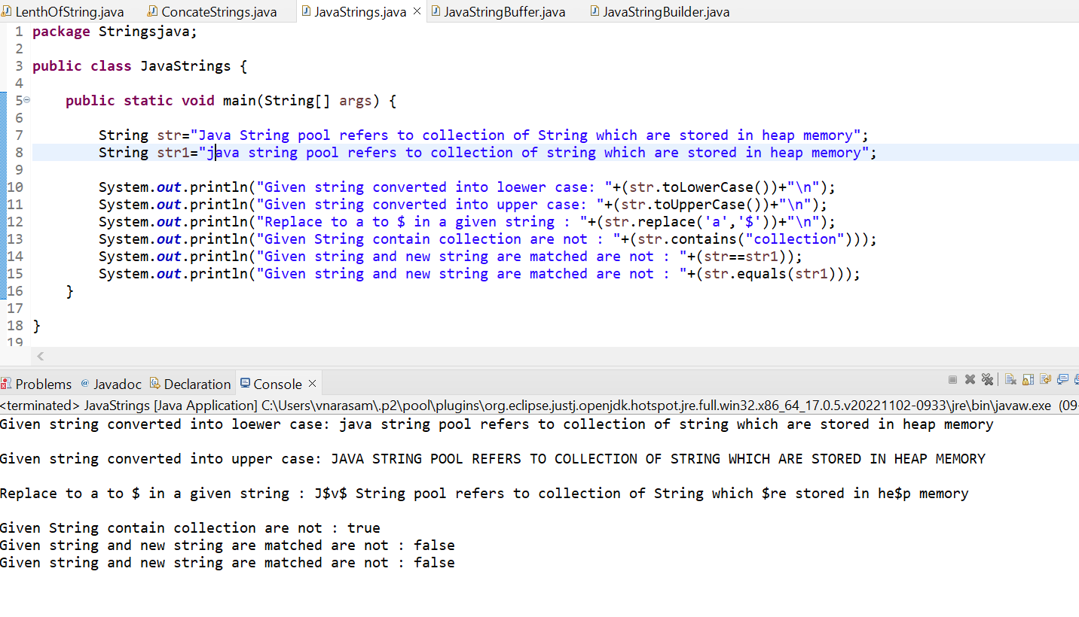

1. String Buffer is used to perform some operations:

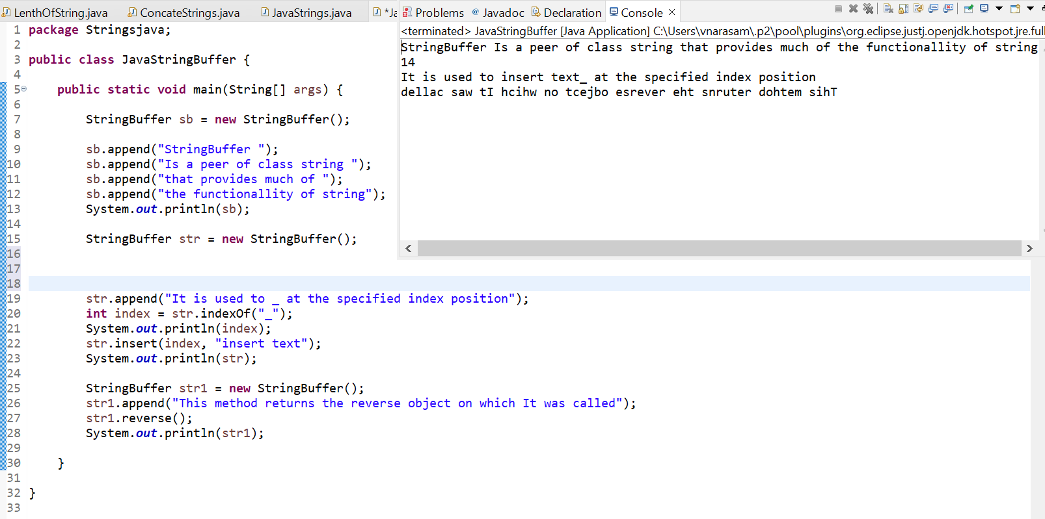

1. String Builder is to perform following operations:

